Objective: To assure that employees are prepared for driving in winter conditions

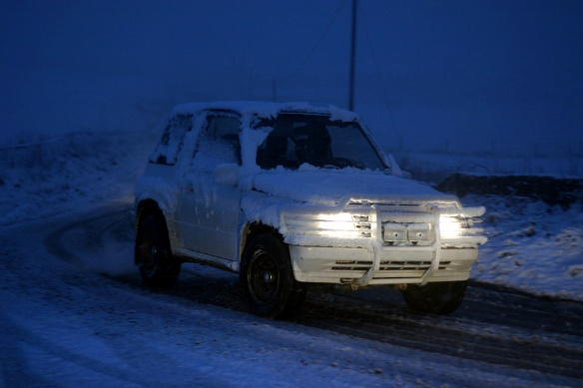
A little extra preparation is needed to assure driver safety during winter months or other inclement weather conditions.
Poor driving conditions is one of the biggest winter safety concerns. Due to shorter days, drivers are required to spend more time driving in the dark, and inclement weather can create slick roads and low visibility conditions.
Safe Practices for Winter Driving
- Give yourself adequate time to reach your destination. Allow for an extra 5 – 10 minutes in your trip for poor weather and road conditions.
- Leave plenty of space for other vehicles. Increase your following distance to compensate for reduced reaction times and longer braking distances.
- Increase your visibility to others. Use your headlights to assure your vehicle is visible to other drivers.
- Keep your vehicle properly maintained. Assure that vehicle components such as the battery, tires, brakes, lights, wipers, and fluid levels are in adequate condition before starting to drive.
- Keep emergency supplies in your vehicle at all times. Make sure that your vehicle contains extra blankets, tire chains, emergency signals or flares, and nutritious dried or canned food.
- Know who to contact in the event of an accident or breakdown.
- Keep your phone charged. Assure that you will be able contact emergency services.

This form documents that the training specified above was presented to the listed participants. By signing below, each participant acknowledges receiving this training.

Organization: Date:

Trainer: Trainer’s Signature:

Class Participants:

Name: Signature:

Name: Signature:

Name: Signature:

Name: Signature:

Name: Signature:

Name: Signature:

Name: Signature:

Name: Signature:

Name: Signature:

Name: Signature:

Name: Signature:

Name: Signature:

Name: Signature:

Name: Signature:

Name: Signature:

Name: Signature:

